
School of Future Tech
CASE STUDY

QUANTITATIVE ASSET PORTFOLIO MANAGEMENT

Rima Maji (150096725215)
B.Tech in CSE
ITM Skills University
Data Structures and Algorithms Using C++
INDEX

1. Introduction to the Case Study
2. Problem Statement / Abstract
3. Objectives
4. Case Study Design / Architecture
5. Methods & Algorithms Used
6. Complexity Analysis
7. Implementation Details and Snapshots
8. Results and Findings
9. Conclusion
10. GitHub Repository Link
11. References

- INTRODUCTION TO THE CASE STUDY
Portfolio management plays an important role in the financial sector by helping investors manage assets, monitor stock performance, and make informed investment decisions. Traditional portfolio management often requires handling large amounts of financial data and processing various operations efficiently.
This case study presents the design and implementation of a Quantitative Asset Portfolio Management System using C++. The system allows users to manage client portfolios, maintain stock records, process trade orders, perform risk analysis, and analyze financial networks.
The project demonstrates the practical application of Data Structures and Algorithms such as Hash Maps, Queues, Stacks, Merge Sort, Graphs, and Dijkstra’s Algorithm in solving real-world portfolio management problems. The system provides efficient portfolio management, stock searching, trade execution, risk evaluation, and portfolio optimization features through a menu-driven interface.

- PROBLEM STATEMENT / ABSTRACT
Managing investment portfolios requires efficient handling of stock information, client records, trade orders, and risk assessments. Manual management of these operations can become complex and time-consuming when dealing with multiple clients and financial assets.
This project aims to develop a Quantitative Asset Portfolio Management System using C++. The system enables users to manage client portfolios, maintain a stock database, process trade orders, perform portfolio risk analysis, and represent financial relationships through graphs.
Various Data Structures and Algorithms are integrated into the system to improve performance and efficiency. Hash Maps are used for fast stock searching, Queues for trade order processing, Stacks for dividend management, Merge Sort for portfolio ranking, and Graphs with Dijkstra’s Algorithm for financial network analysis and route optimization.

- OBJECTIVES
• Manage multiple client portfolios efficiently.
• Maintain a stock database for analysis and searching.
• Implement fast stock lookup using Hash Maps.
• Process trade orders using Queue data structure.
• Manage dividend operations using Stack.
• Sort portfolios using Merge Sort.
• Analyze portfolio risk levels.
• Represent financial entities using Graphs.
• Find the lowest risk route using Dijkstra’s Algorithm.
• Generate portfolio insights and summary reports.

- CASE STUDY DESIGN / ARCHITECTURE
The project follows a menu-driven architecture where client portfolios and stock records are managed through different modules.

Workflow:
Client Portfolio Records
↓
Stock Database Management
↓
Trade Order Processing
↓
Dividend Management
↓
Portfolio Risk Analysis
↓
Financial Network Analysis
↓
Portfolio Optimization & Summary

The system integrates multiple Data Structures and Algorithms to ensure efficient data management and financial analysis.

- METHODS & ALGORITHMS USED
Data Structures Used
- Hash Map (unordered_map)
Purpose: Fast stock searching using stock ticker symbols.
- Queue
Purpose: Trade orders are processed in First-In-First-Out (FIFO) order.
- Stack
Purpose: Stores dividend history and supports undo operations.
- Vector
Purpose: Stores client and stock records.
- Graph
Purpose: Represents financial institutions and their relationships.
Algorithms Used
- Merge Sort
Purpose: Sort client portfolios according to portfolio value.
- Dijkstra’s Algorithm
Purpose: Find the lowest risk route in the financial network.
- Risk Analysis Algorithm
Purpose: Categorize clients into LOW, MEDIUM, and HIGH risk groups.
- Portfolio Balancer
Purpose: Provide investment diversification suggestions.

6. COMPLEXITY ANALYSIS
Operation | TimeComplexity
Stock Search | O(1)
Trade Insertion | O(1)
Trade Processing | O(1)
Dividend Push | O(1)
Dividend Undo | O(1)
Portfolio Sorting | O(n log n)
Risk Analysis | O(n)
Financial Network Display | O(V+E)
Lowest Risk Route | O(V²)
Project Summary | O(n)

Space Complexity
- Client Records : O(n)
- Stock Records : O(n)
- Queue : O(n)
- Stack : O(n)
- Graph : O(V + E)
- Merge Sort : O(n)

- IMPLEMENTATION DETAILS AND SNAPSHOTS
Implementation Details
The project is implemented using C++ and follows a modular approach.

Modules Implemented:
• Client Portfolio Management
• Stock Database Management
• Stock Search System
• Trade Order Placement
• Trade Processing System
• Dividend Management
• Portfolio Sorting
• Risk Analysis
• Financial Network Representation
• Lowest Risk Route Analysis
• Portfolio Balancer
• Project Summary Dashboard
Snapshots
- Main Menu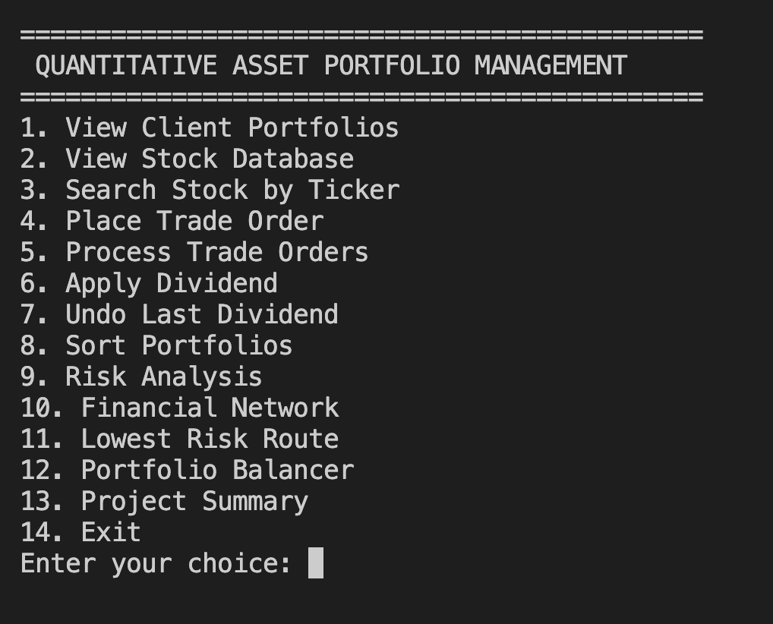
- Stock Search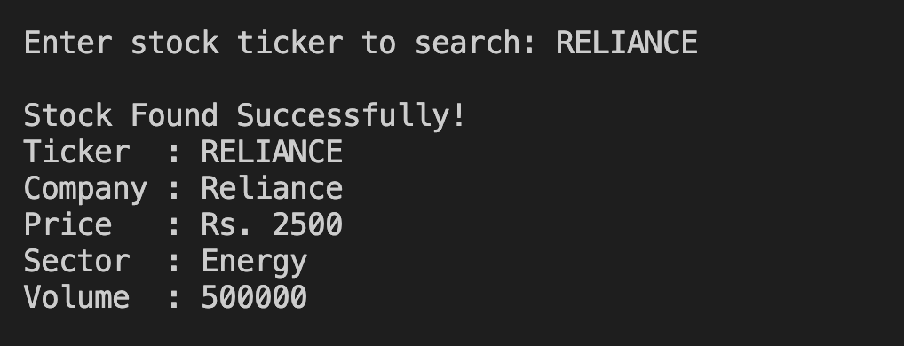
- Trade Order Placement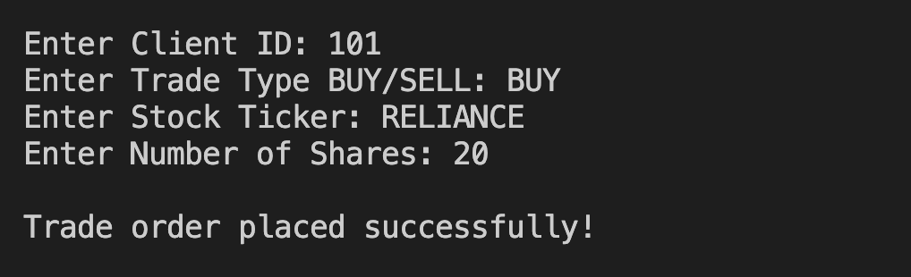
- Trade Processing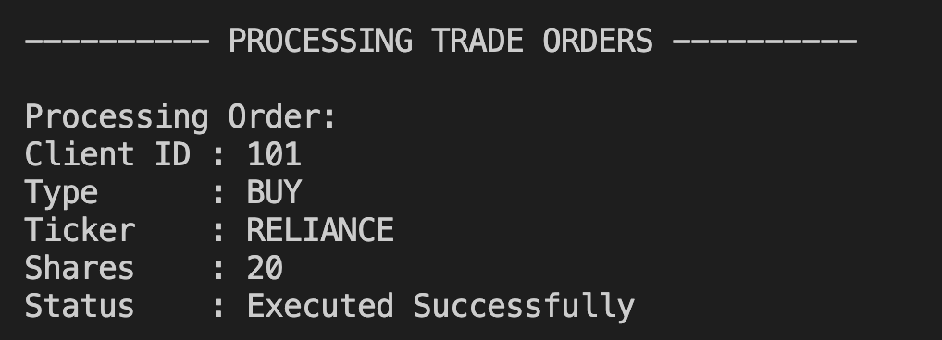
- Apply Dividend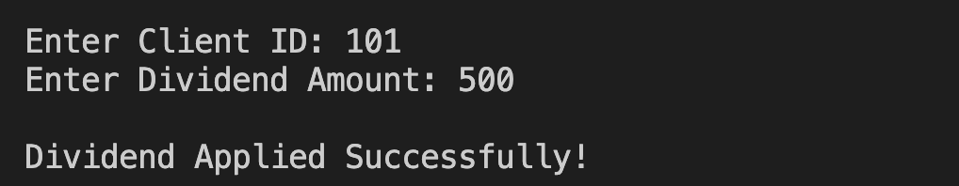
- Undo Dividend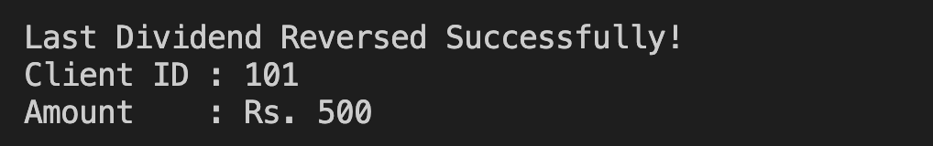
- Portfolio Sorting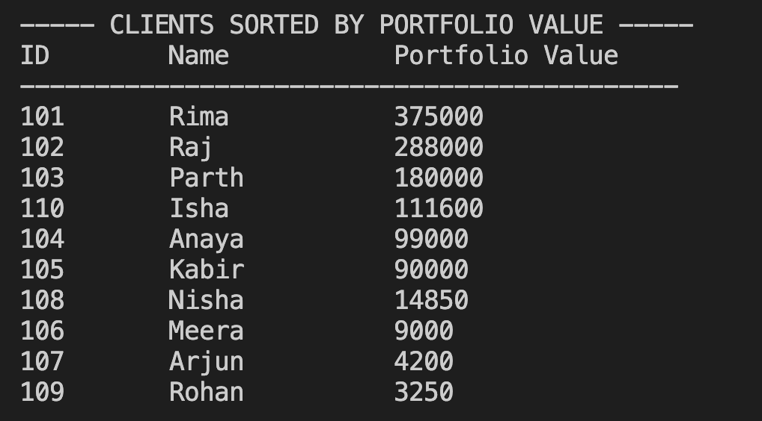
- Risk Analysis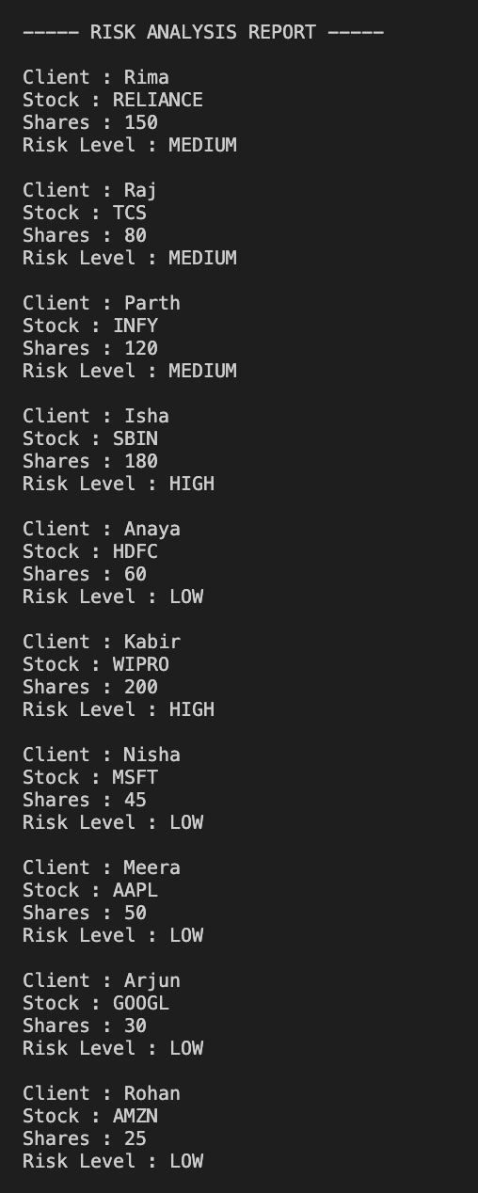
- Financial Network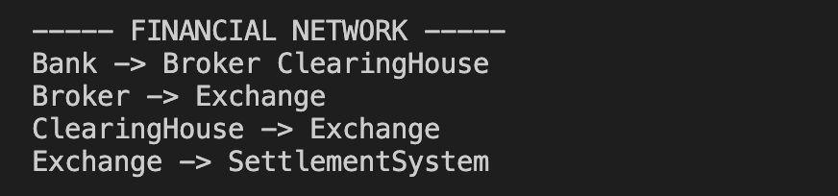
- Lowest Risk Route 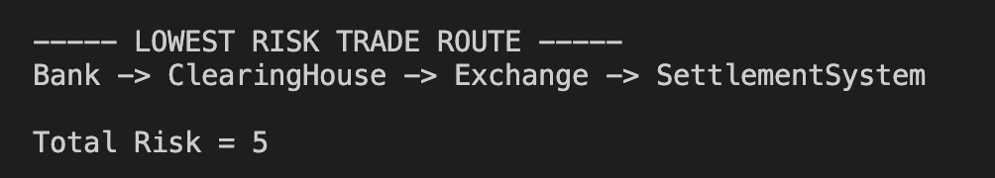
- Portfolio Balancer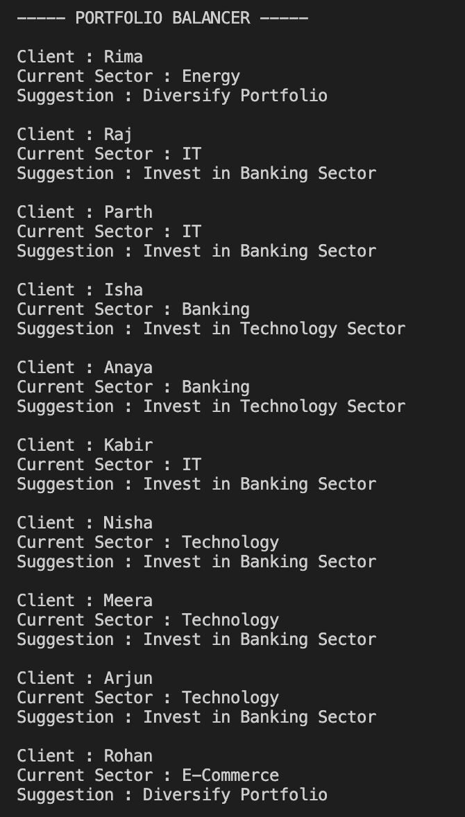
- Project Summary Dashboard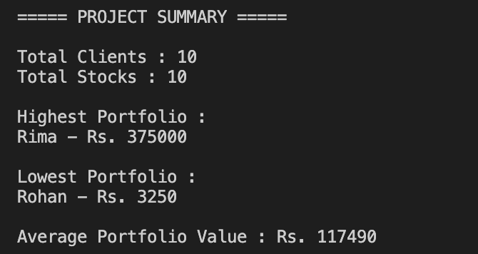

- RESULTS AND FINDINGS
The project successfully demonstrates the application of Data Structures and Algorithms in portfolio management.
Findings:
• Hash Maps provide efficient stock searching operations.
• Queue ensures proper trade execution order.
• Stack enables dividend undo functionality.
• Merge Sort efficiently ranks portfolios based on portfolio value.
• Graph structures effectively represent financial relationships.
• Dijkstra’s Algorithm successfully identifies the minimum-risk route.
• Risk Analysis categorizes portfolios into different risk levels.
• Portfolio Balancer assists in diversification recommendations.
• Project Summary Dashboard provides useful portfolio insights.

- CONCLUSION
The Quantitative Asset Portfolio Management System was successfully implemented using C++ and multiple Data Structures and Algorithms.
The project demonstrates the practical use of Hash Maps, Queues, Stacks, Merge Sort, Graphs, and Dijkstra’s Algorithm in solving real-world portfolio management problems. The system provides efficient portfolio management, trade processing, risk analysis, financial network modeling, and portfolio optimization while maintaining good computational performance.

- GITHUB REPOSITORY LINK
- GitHub Repository:
https://github.com/rimam02/DSA_1_Main_CS

- REFERENCES
• C++ Official Documentation
• GeeksforGeeks – Data Structures and Algorithms
• Course Notes for Data Structures and Algorithms Using C++
• GitHub Repository of the Project
• Academic references related to Portfolio Management and Financial Analysis

